 | Chatham Nursery School  Special Educational Needs and Disabilities Policy
Mission Statement
Our nursery school community is dedicated to supporting every child to be a happy, confident and independent learner.
We create a caring, inclusive and enriching learning environment where each child can feel safe, supported and valued.

Rationale
This policy complies with the Children and Families Act 2014 and the Special Educational Needs and Disabilities (SEND) Code of Practice 0-25 (Department of Health, Department for Education, 2015) and has been written with reference to the following guidance and documents: Equality Act 2010: advice for schools (DfE, Feb 2013) Schools SEND information report regulations (2014) Statutory guidance on supporting pupils with medical conditions (DfE, August 2017) Child Protection Policy and Accessibility plan.

At Chatham Nursery School we are committed to providing high quality first teaching to all children attending our nursery. We believe that all children should be equally valued in school. We will strive to eliminate prejudice and discrimination and develop an environment where all children can flourish, feel safe and become confident and successful learners.
Practice
We aim to work in partnership with parent/s and carers to identify the uniqueness of each child and recognise each child’s particular abilities, strengths and level of development.

We believe that educational inclusion is about equal opportunities for all
learners, whatever their age, gender, ethnicity, impairment, attainment and background. We pay particular attention to the provision for and the achievement of different groups of learners.
- Girls and Boys
- Minority, ethnic and faith groups, travelers, asylum seekers and refugees.
- Learners who need support to learn English as additional language (EAL)
- Learners with Special Educational Needs
- Learners who have a disability
- Those who are gifted and talented.
- Those who are looked after by the Local Authority
- Those who have specific medical needs and those who are in families under stress.
- Any learners who may be at risk of disaffection and exclusion.

We liaise and work with a range of professionals to ensure all children and their families receive appropriate support. We aim to provide a learning environment that reflects these values and offers all children a broad, balanced and stimulating range of learning opportunities.

Provision for children with Special Educational Needs is made with due reference to the SEN Code of Practice dated 1st September 2014.

SEND Curriculum
Chatham Nursery School has an established system for regularly observing, assessing and recording the progress of all children and is used to identify children who are not progressing satisfactorily and who may have additional needs.

The school’s particular arrangements for assessing and identifying pupils as having SEN also form a part of our published Local Offer which was produced in consultation with parents in cooperation with the Local Authority and with due regard to the general duties to promote disability equality.
We recognise the definition of SEN as stated in the Code of Practice 2014:

“A pupil has SEN where their learning difficulty or disability calls for special educational provision, namely provision different from or additional to that normally available to pupils of the same
age”. (p83)

The school reflects what the Code of Practice states (p88 sect 637) in that pupils are only identified as SEN if they do not make adequate progress once they have had all the interventions/adjustments and good quality personalised teaching. This is known as ‘SEN Support’.

We fully adopt the graduated approach to ensure that all pupils with special educational needs and/or disabilities are identified early, assessed and catered for within the school/setting with high expectations for the best possible progress;

The four broad areas identified within the SEN Code of Practice 2014 (p86) are
- ‘Communication and Interaction’,
- ‘Cognition and Learning’,
- ‘Social, Emotional Mental Health Difficulties’
- ‘Sensory and/or Physical needs’
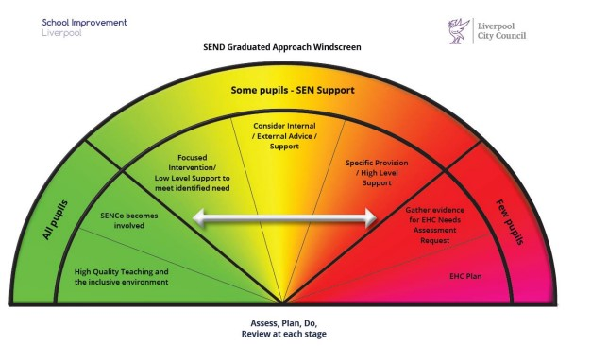
We work within a ‘person centered approach’ fostering and promoting effective collaboration with children/young people, parents/carers and outside agencies; Underpinning ALL our provision in school is the graduated approach cycle of:
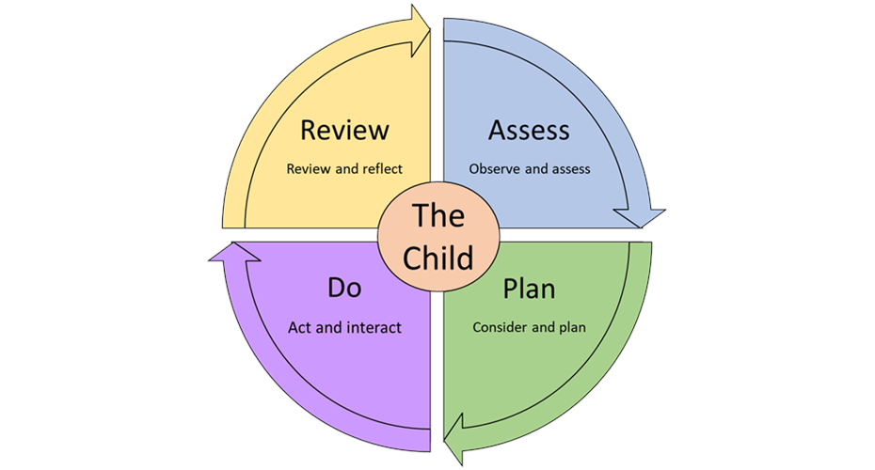
In order to make progress a child may have their needs met through normal teaching/learning strategies e.g. Small group activities, language enrichment groups or one to one Key Person time. Their progress is monitored by their Key Person, Class teacher and Head of school.
If a parent/carer has concerns or thinks their child may be having difficulties at home or in school or a special need that has not been identified then an appointment can be made to discuss this with their child’s Key Person or Class Teacher. They will then discuss any concerns with the nursery SENCO.
We pride ourselves on ensuring that parents/carers are involved early with any difficulties their child may appear to be having. An individual play plan may be introduced for your child. This will involve setting specific achievable individual targets for your child to work towards.
Some children need a more tailored approach to address a specific Special Educational Need that is impacting on their ability to learn. This will be discussed with you by the school SENDCo. If your child continues to have difficulties, despite targets set then the SENDCo may discuss with you the need to involve specialist services.
Although the SENCO has overall responsibility for the identification of pupils with SEND in the school it is recognised that all staff have a key role to play in this process. This is part of the collective responsibility and collaborative approach of the school.
There are activities available across the ability range (including the very able) to allow for adaptive teaching and differing developmental needs and learning styles. Work is planned to extend and develop the children’s skills through play. The teaching styles are sensitive and responsive to the children’s needs and the class staff work throughout the classroom areas to support the children in determining their own learning. Staff intervene and encourage when necessary and appropriate.
Access to a range of sensory resources and materials are provided and a sensory room is available for use. Appropriate resources to support access to all areas of play and learning will be provided wherever possible to support the inclusion of all children regardless of their ability or special need.
Interventions

Where a child continues to make less than expected progress despite evidence based support matched with interventions addressing areas of need it may be necessary to involve specialists in the school or from outside agencies. Parents will always be informed and involved in the decision to procure the advice of a specialist and their consent will be required formally by agencies. (Except in child protection cases where a child is deemed to be at risk).
Where assessment indicates that support from specialist services is required the school strives to ensure that the pupil receives this as quickly as possible. The Local Offer sets out clearly what support is available. Support Services used in Chatham Nursery School include for example;
- Educational Psychology,
- Speech and Language Therapy Services
- MAST
- OSSME
- Autistic Spectrum Disorder Pathway Team
- Social Workers
- Community Pediatricians
- Physiotherapists
Some children may have multi-agency involvement and the school will consider the criteria for the levels of need and where relevant may decide in consultation with Liverpool’s ‘Responding to Need Guidance and levels of Need Framework’ that an EHAT (Early Help Assessment Tool) is appropriate.
At all stages of the SEN process the school keeps parents/carers fully informed and involved. Regular meetings are scheduled throughout the academic year to share the progress of the pupils with parents/carers and to take account of their views. It is hoped that this will assist in supporting pupils to reach their full potential. Parents/carers are encouraged to make a full and active contribution to their child’s education and are encouraged to contribute and share information in their child’s profile on Tapestry.

The SENCO attends SEN briefings and cluster meetings to update and revise developments in Special Educational Needs and Inclusion.
The SENCO is responsible for monitoring and evaluating the teaching practices and provision for all students, including those with SEND, and providing feedback to staff on strengths and areas for improvement. This is achieved through a variety of methods, including observations, learning walks, work scrutiny, and monitoring of support plans. The SENCO formally observes teaching and support staff at least once a year, with additional informal observations taking place. Feedback is provided on their practice, highlighting both strengths and areas for development.
Each term, the SENCO meets with every class team to collect and share feedback regarding the provision for students with SEND. Additionally, the SENCo holds meetings with the SEND Governor to enable the Governing Body to assess and monitor the school’s SEND provision. Feedback from parents and carers is collected at review meetings, parent/carer events, and through annual surveys.
As part of their Performance Management process, all staff are given targets aligned with the school’s Development Plan to help enhance their practice. Following training sessions and interactions with external support agencies, staff are required to complete feedback forms outlining what they have learned, how they will apply this knowledge, and any support they need to do so.
The SENDCo monitors the progress and attainment of students with SEND every half term, and this information is incorporated into the school’s overall monitoring process. The effectiveness of interventions is reviewed both termly and annually, and adjustments are made where necessary to ensure provision meets the needs of students with SEND and aligns with the school’s priorities.
The quality and effectiveness of the Resourced Provision for students with more complex SEND are closely monitored by the Local Authority in partnership with the SENCo.
Additionally, SEND provision undergoes an annual assessment by an external evaluator as part of the school’s commitment to maintaining its status as an Inclusion Quality Mark ‘Centre of Excellence’.
Chatham Nursery School is a member of the Primary SEND support partnership that share best practice and offers support within the locality. Training on SEND is arranged through these meetings with the support and involvement of the services attached to these, the training is needs led and linked to the school development plan, needs of the particular consortia and the school’s Local offer.
All staff are committed to developing their knowledge and skills in relation to SEND, they attend courses organised by the LA and take part in in-house training sessions, often with invited trainers from other agencies to assist them in acquiring the skills needed to work with pupils with SEND.
Specialist SEND Unit
We have a small but successful specialist unit for those children with significant additional needs – “The Nest” which offers an individualised curriculum adhering to the needs of all the children in this class. The room is equipped to meet the needs of the children and there is an outdoor area attached so that the children in this room have free flow outside. Ratios are higher in this room with 1 staff to 2 children. Eligibility for this room will be assessed by a LCC SEND Early Years Officer and places will be allocated by a Placement Process Panel.
Complaints Procedure
If parents / carers wish to complain about the SENDs provision within the Nursery School they are invited to discuss this with the SENDCo, then if necessary, with the Head of School and finally, if unresolved, with the SEND Governor. All complaints follow the school`s complaints procedure.

The full governing body remains responsible for Special Educational Needs and Disabilities within the school

The Special Education Needs and Disabilities Co-Ordinator is Sara Atkinson,
Hours of work, Wednesday-Friday 8.30am- 3.30pm
Contact Details: Tel: 0151 233 1201
Email: chatham-ao@chathamplace.co.uk
The SEND Governor at Chatham Nursery School is Mary Jackson.

Please allow 5 working days for a response. If your enquiry is of an urgent nature do not hesitate to speak with the school office or email chatham-ao@chathamplacenursery.co.uk
The SEND Governor at Chatham Nursery School is Mary Jackson and she can be contacted via the Head of School or Chair of Governors.
Monitoring and review
This policy was agreed and implemented on 8th September 2025 and is due for review in
October 2026.

