All About Me

Please stick a recent photo of your child here

We believe that you are your child’s first teacher. We value your contribution and hope this will be the beginning of a vital partnership between you and our staff during the time your child is with us. The following activity is a way of letting us know some details about your child with his/her active involvement. It will be a starting point for discussions and conversations that staff will have with your child.

Thank you for taking the time to complete the information

If you would like help filling in this form please ask a member of staff


All About Me

Name: | Date of Birth: | Date:

My Picture: {encourage your child to draw a picture of themselves on this page. The image doesn’t need to be perfect or recognisable}

Communication and Language

What language/s are spoken at home?

What language/s does your child speak?

Does your child enjoy listening to stories?

Does your child have a favourite story?

Can your child retell a story?

Does your child enjoy nursery rhymes and songs?

What songs and rhymes does your child know?

Does your child use single words /use two words together/ three words together or speak in full sentences?

Does your child ask you questions?

Is it easy for others to understand your child’s talk?

Can your child answer a question e.g. What’s that?, Where’s my bag?
Can your child understand 2/3 part instructions e.g. Put the apple in the bowl or Put the green sock in the washing machine

Who lives with your child?

Who are your child’s important people?

What does your child call them?

Has your child had any previous nursery or playgroup experience?

Did it take your child a long time to settle? What help or support did they need?

Does your child have experience of playing with the children of your friends or family?

Does your child have a special friend?

Will your child approach another child to play?

Does your child respond to praise from an adult?

How confident is your child when away from you?
Will your child approach an adult if they need help?

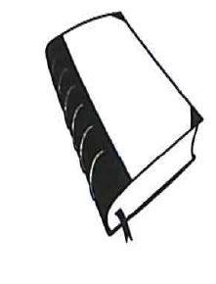Behaviour
Can your child express his/her feelings such as happy, sad, angry?
How can we calm your child if they get upset?
Has your child had experience of sharing and taking turns?

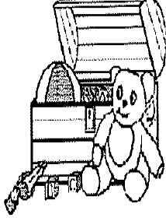What are your child’s favourite toys?

Tell us how your child moves around. Can they move freely and run/skip/hop/jump?

Can your child use pencil and crayons?

Do they enjoy playing with dough/sand and water?

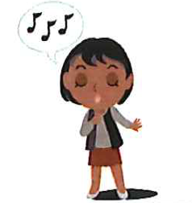What songs does your child like to sing?

Does your child have any fears or dislikes?

Do you have any concerns about your child’s:
Vision
Hearing
General Health

Self help skills e.g. toileting, eating
Is your child fully toilet trained?

Does your child have the occasional accident?

What kind of help does your need?

Does your child know how to dress /undress themselves- what can your child do?
Does your child use their fingers to feed themselves?

Can your child use a knife/ fork and spoon?

Sleep
Does your child have a good daily sleep pattern?
Will they need a nap while they are with us?

Any concerns or anything you would like us to know thatwill help your child settle into nursery ?

